First Reconciliation 2022

Our Lady Queen of Peace Church & St Joseph’s School Payneham

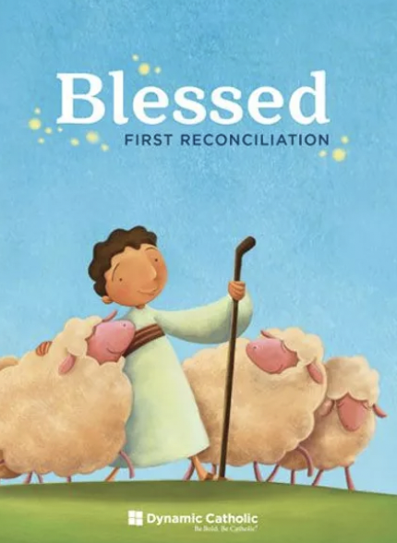

BLESSED -First Reconciliation program for parents and children –
We are using the Dynamic Catholic First Reconciliation Preparation Program.
All program materials are fully available online;
Each of the links below will bring you to a particular Session (1 through 6). Please click on heading to access the relevant session and its episodes. Once the page opens, please scroll to the bottom and you will find the seven short video presentations. Just click on the one you want to watch with your child and enjoy. The Workbook will support you if you would like to go deeper into the content of each video. ENJOY!!!

First Reconciliation

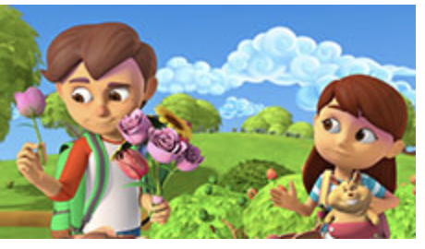
1. Complete Session 1 book reading and videos. Practice the Act of Contrition.
2 “Show What You Know” activity page on pgs. 24-25
3. The Bible story that goes with this lesson is on pgs. is the story of the lepers in Luke 17:11-19 in your Catholic Bible or at https://bible.usccb.org/ under the Bible and Books of the Bible tabs.

The Best Version of Yourself

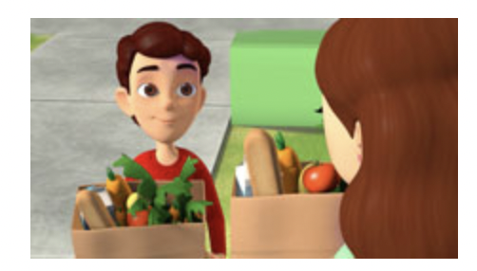
1. Complete Session 2 book reading and videos. Practice the Act of Contrition.
2. “Show What You Know” activity page on pgs. 62-63
3. THE Bible stories are pgs. 30-31 and 38-39 are Exodus 3:1-15 and Exodus 20:1-17 in your Bible or https://bible.usccb.org/

God Sent Jesus to Save Us
School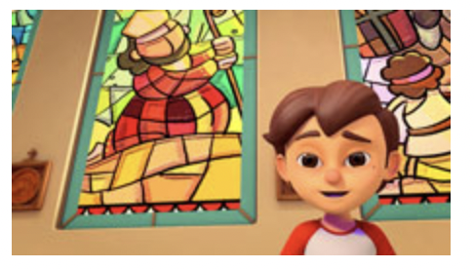
1.Complete Session 3 book reading and videos. Practice the Act of Contrition.
2. “Show What You Know” activity page on pgs. 98-99
3 The Bible stories are pgs. 200-211 and 212-219 of your child’s Bible. Matthew 27: 1-61 and Matthew 28:1-20 or https://bible.usccb.org/

Forgiveness and Healing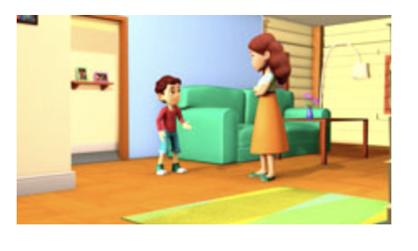
2. Complete Session 4 book reading and videos. Practice the Act of Contrition.
3. “Show What You Know” activity page on pgs. 128-129
4. The Bible stories are pgs. 132-133 and pg. 183.
Matthew 6:9-13 and John 10:1-21 in your Bible or https://bible.usccb.org/

Your First Reconciliation

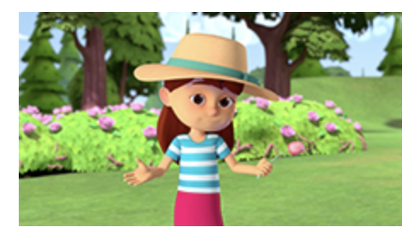
1. Complete Session 5 book reading and videos. Practice the Act of Contrition.
2. “Show What You Know” activity page on pgs. 170-171
3. Bible stories are pgs. 176-177. Luke 15:11-32 in your Bible or https://bible.usccb.org/

It's Only the Beginning

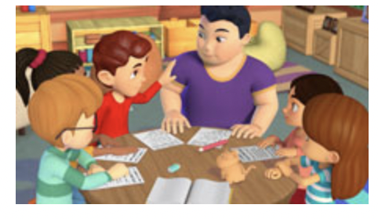
1.Complete Session 6 book reading and videos. Practice the Act of Contrition.
2. “Show What You Know” activity page
A step-by-step guide to Reconciliation for Children

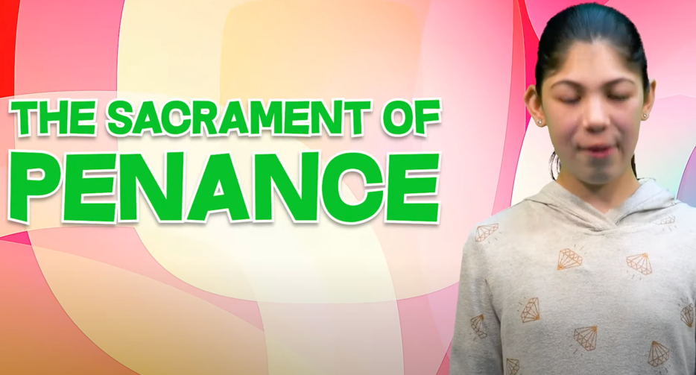

https://www.youtube.com/watch?v=NHSFUlf3fkc

Children talk about the Gospel story of God our loving Father (Luke15:11-24) as they prepare for Reconciliation.
https://www.youtube.com/watch?v=4Nx1nD-YaKs&t=211s

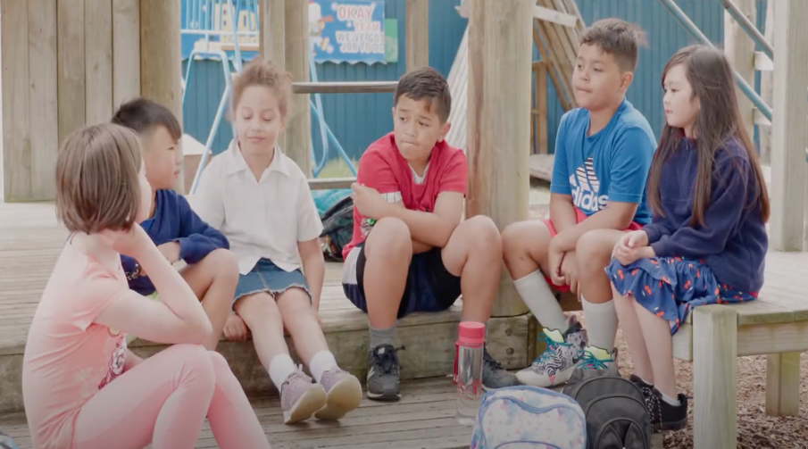
Show What You Know
Session 1
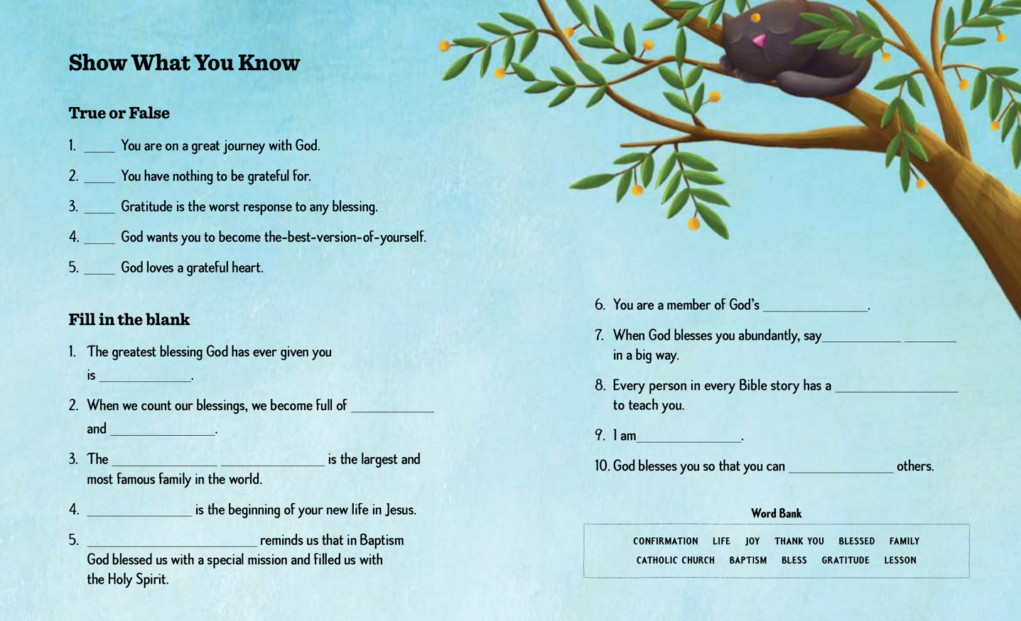
Session 2
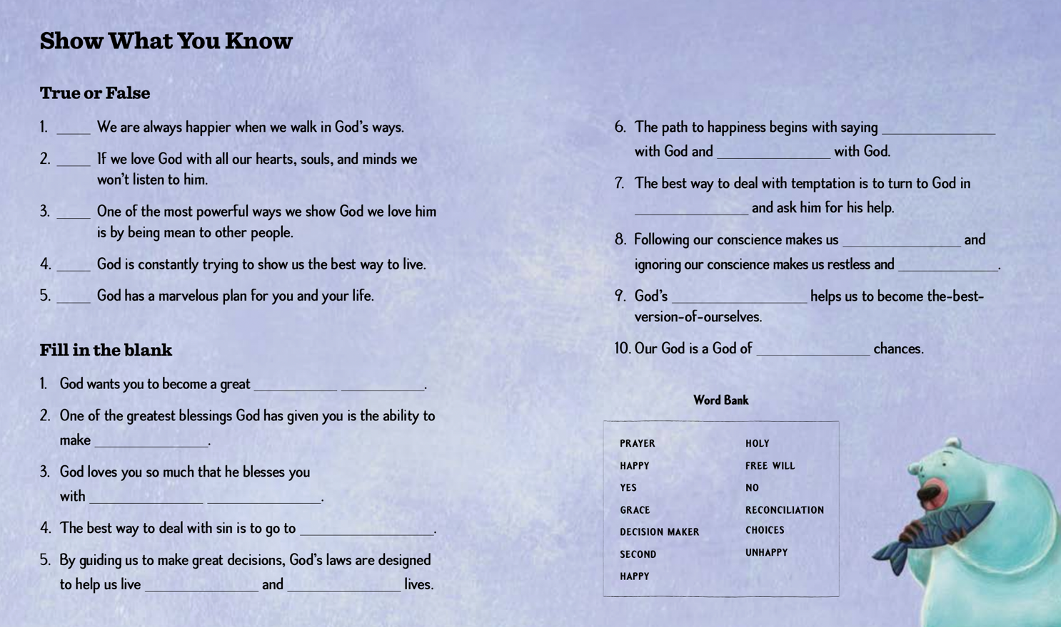

Session 3
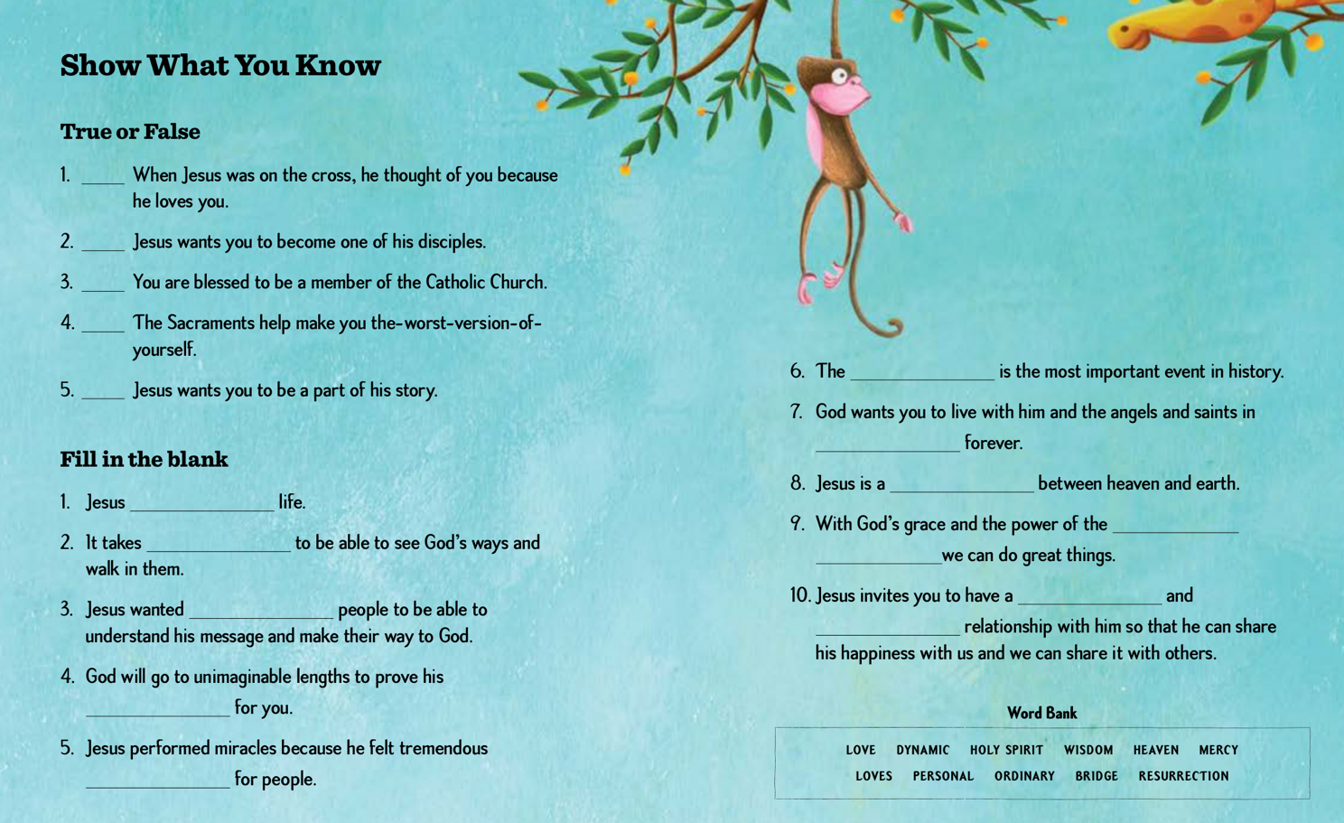
Session 4
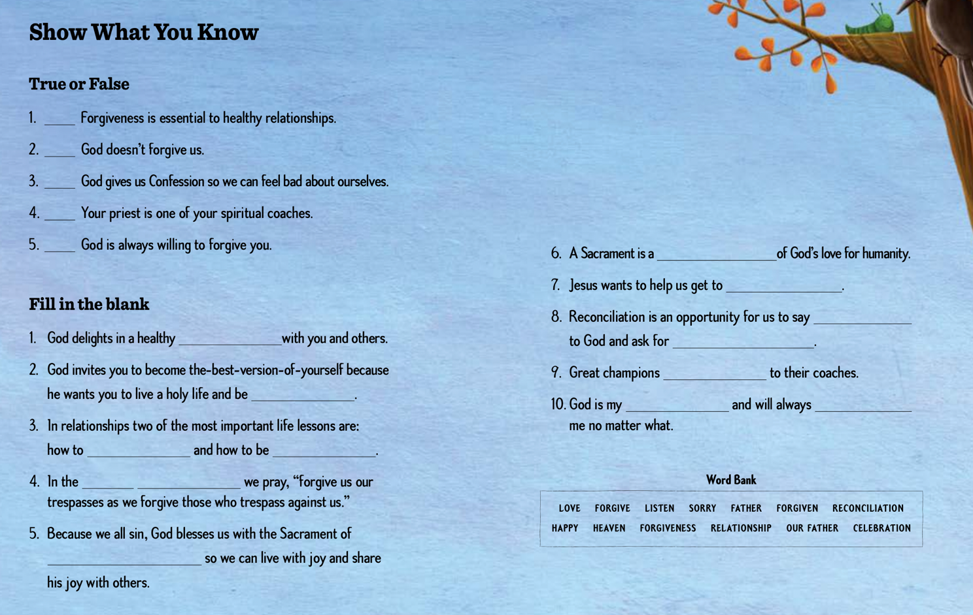

Session 5
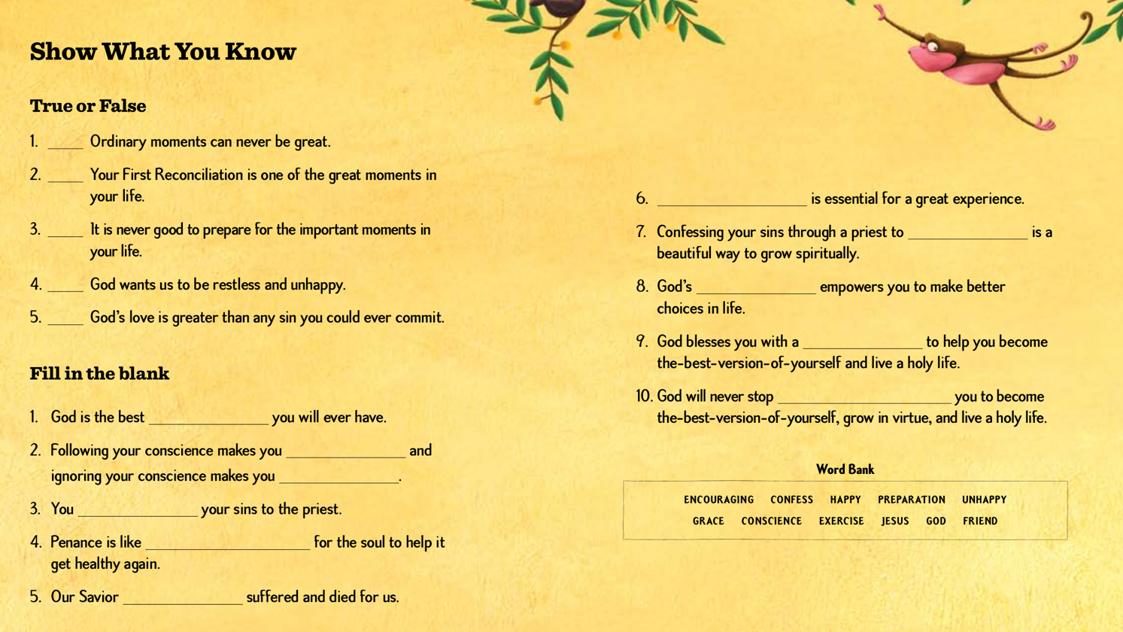

Session 6
