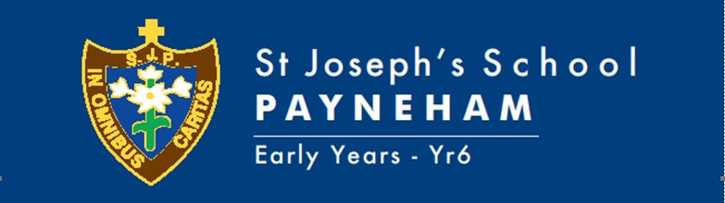

TERM THREE, 2021 OVERVIEW, YEAR 2
TEACHERS: Shendelle Watters, Tania Melfi, Michael Musolino
Welcome to the Term Three learning for the Year 2 classes.
Student learning will focus on:
Religion (New Crossways)  New MITIOG  (Made in the image of God) | Jesus taught the importance of forgiveness  (we can choose right from wrong)  Mary MacKillop  The Assumption of the Blessed Virgin Mary  Human Sexuality (MITIOG)  - An appreciation of the dignity of the human person  - Promote respectful body awareness and understanding that we are called to show God’s love to others  - Family is ideally a place for a child to be loved and nurtured, a safe place where a child learns  - An appreciation of the body as a special gift  - Correct terminology to name the parts of the body.
Child Protection Curriculum | Recognising and Reporting Abuse
English | Heggerty (Phonics)  Phonemic Awareness Program  Handwriting  Book Week (Old Worlds, New Worlds and Other Worlds)  Guided Reading (Decodable and levelled Readers)  Narrative Writing  Recount Writing
Mathematics | Transformations (Slide, turn, flip)  Mass and Volume  Fractions (Halves, quarters and eighths)  Time (Quarter past, quarter to, digital/analogue)  More or less  Counting Collections to 1000  Counting Strategies  Addition and Subtraction
Science | Water Works (Earth & Space Sciences)
Humanities and Social Sciences (HASS) | Our local community (A significant place)
Health | Sustainability (KESAB Paper making incursion)
Physical Education | Michael Musolino curriculum link
Italian | Emily Parrella curriculum link
Arts | Significant artworks from around the world  Father’s Day art
Music | Emma Hills curriculum link
STEM | Nicholas Polvere curriculum link
Information Technology | Using an ipad (including various apps)  SEESAW (Editing skills including colour, shapes, uploading work, taking photos/videos, caption box, text box, video link, audio, background, uploading screenshots, inserting new pages, drawing tool)  Internet  Logging in to the School Intranet
Design and Technology | Making a Rain Gauge  Paper Making (with KESAB)

SPECIAL EVENTS THIS TERM
Masses | Mary of the Cross MacKillop - 9th August (Week 4, Term 3)  Assumption Mass (Yr3-6) - 13th August (Week 4, Term 3)  Year 2 Unit Mass - Monday 23rd July (Week 6, Term 3)
Assembly | N/A
Excursions/Incursions | KESAB Incursion - Monday 16th September (Week 5, Term 3)
Pupil Free Days | 24th September
Parent/Teacher/Student Dates | Book Week Parade – Thursday 26th August (Week 6, Term 3)  School Photo Day – Friday, 27th August (Week 6)
Holidays | Friday 23th September - Term 3 holidays 3pm

HOMEWORK FOCUS – HOW TO HELP AT HOME
Spelling | Weekly Literacy Homework contract
Reading | Home reading for a minimum of 10-15 minutes. Please encourage and discuss with your child the content of the text they are reading. At this stage of development, we also encourage the children to be reading for pleasure. It is of benefit for children to read a variety of materials for example: novels, recipes, informational texts, appropriate newspaper articles, web-based texts etc.
Mathematics | N/A
Other | At various times throughout the year your child will be given investigation tasks within the curriculum areas.
Library Borrowing Day | 2MM – Thursday  2W - Friday
PE Days  (PE uniform to be worn) | Monday and Wednesday
Useful Websites | Studyladder (students will have a login) - Literacy, Numeracy and other areas.
Parent Information | SEESAW
Key contact details | swatters@stjopayn.catholic.edu.au  tmelfi@stjoapyn.catholic.edu.au  mmusolino@stjopayn.catholic.edu

