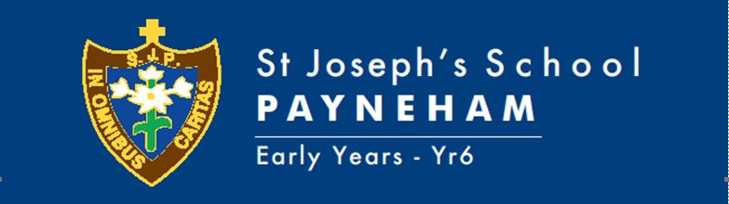

TERM THREE, 2021 OVERVIEW, YEAR 5
TEACHERS: Matthew Annetta & Yvette Vingelis & Adriana Graziani
Welcome to the Term Three learning for the Year 5 class.
This term, student learning will focus on:
Religion (New Crossways)  New MITIOG (Made in the image of God)  Links | Power Brings Change: What was Jesus’ law of love, and how can Iive it?  *God, Us and Faith  *Church for the World  Made in the Image of God:  *Identity  *Relationships  *Human Development  *Reproduction and Reproductive Health
Child Protection Curriculum | Identity and Relationships:  *Exploring relationships  *Healthy and Unhealthy Relationships  Trust and Networks:  *Trusted Networks  *Privacy and the Body
English | Writing:  *Report Writing  -locating appropriate sources, researching, note taking, referencing, rephrasing  Reading:  *Guided Reading, Independent  Spelling/ Functional Grammar:  *Jolly Phonics
Mathematics | Rules for Base Ten: Lisa Jane O’Connor  Recalling Number Facts: Lisa Jane O’Connor  Measurement and Geometry:  *Angles  *Transformation  *Location  Statistics and Probability:  *Data Representation and Interpretation
Science | Physical Science:  *Light Shows
Humanities and Social Sciences (HASS) | Geography:  *Factors that Shape Places  Economics and Business:  *Wants, Resources and Choices
Health | Being Healthy, Safe and Active  *influences of people and places  *managing changes and transitions associated with puberty  *strategies to promote health, safety and wellbeing  Contributing to healthy and active communities  *managing relationships  *influences of emotional responses on behaviour and relationships  Communicating and interacting for health and wellbeing  *role of preventative health  *valuing diversity
Physical Education | Michael Musolino curriculum link
Italian | Emily Parrella curriculum link
Arts | Visual Art  *ideas and practices used by Aboriginal and Torres Strai Islander artists  *visual arts (Street Art) conventions communicate meaning – social, cultural, historical contexts
Music | Emma Hills curriculum link
STEM | Nicholas Polvere curriculum link
Information Technology | Digital Technologies Knowledge and Understanding:  *main components of common digital systems connecting together to form networks to transmit data  *whole numbers are used to represent data in digital systems
Design and Technologies | Design and Technologies Process and Production Skills: Robots  *Critique needs or opportunities for designing, and investigate materials, components, tools, equipment and processes to achieve intended designed solutions  * Generate, develop and communicate design ideas and processes for audiences using appropriate technical terms and graphical representation techniques  *Select appropriate materials, components, tools, equipment and techniques and apply safe procedures to make designed solutions

SPECIAL EVENTS THIS TERM
Masses | The Assumption of the Blessed Virgin Mary Friday 13th August. 9.30am  St. Mary of the Cross MacKillop Monday 9th August
Assembly | Thursdays Week 3, 6 & 9 at 2.00pm in the Gym.
Excursions/Incursions | TBA
Pupil Free Days | September 24th 2021
Parent/Teacher/Student Dates | August 26th Book Week Parade  August 27th School Photo Day
Holidays | End of Term September 23rd 2021 3pm

HOMEWORK FOCUS – HOW TO HELP AT HOME
Spelling | Weekly contracts uploaded to OneNote weekly
Reading | - Home reading for a minimum of 10-15 minutes. Please encourage and discuss with your child the content of the text they are reading. At this stage of development, we encourage the children to be reading for pleasure. It is of benefit for children to read a variety of materials for example: novels, recipes, informational texts, appropriate newspaper articles, web-based texts etc.
Mathematics | Set tasks to consolidate in class learning.
Other | At various times throughout the year, your child will be given investigation tasks within the curriculum areas.
Library Borrowing Day | As required
Parent Information | Seesaw
Key contact details | mannetta@stjopayn.catholic.edu.au  agraziani@stjopayn.catholic.edu.au  yvingelis@stjopayn.catholic.edu.au

