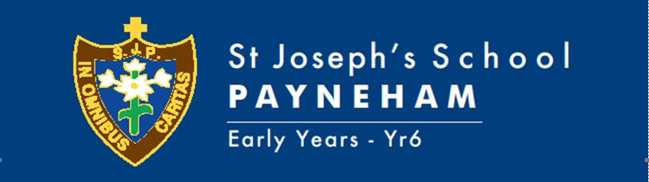

TERM THREE, 2021 OVERVIEW,
Mid Year Reception
TEACHERS: Jane Anthony & Tayla Carosi
Welcome to the Term Three learning for the Mid Year Reception classes. This term we will be engaging in an inquiry unit based on weather. Student learning will focus on:
Religion (New Crossways)  New MITIOG (Made in the image of God)  Links | In Religion this term, we will begin to use the Crossways framework for Early years to structure our lessons. Students will engage in learning through play, allowing them to explore their emotions, develop relationships with others and learn about themselves as children of God.  Students will…  - Explore a variety of images of God and language about God through books  - Explore and identify that God is the creator of all things  - Grow to understand that they have been created through the love of God and are unique and different to eachother.  - Build friendships based on the values of the church  - Know and interact with religious traditions learning how to be respectful and present during prayer.  - Begin to understand and develop a relationship with God and Jesus  Religion will not only be taught through lessons and morning prayer, but authentically embedded into their everyday practise; as they engage with others, build relationships with those in their community and learning about themselves.
Child Protection Curriculum
English | In English this term, we will teach literacy through explicit, evidence-based programs which include Heggerty and Pre-Lit.  Heggerty is a research-based program which specifically targets phomenic and phonological awareness. Whilst, Pre-Lit is a systematic, skills-based program which looks at engaging ways to develop phonogical awareness and oral language development through storybook reading.  Students will…  - Develop phonemic awareness skills  - Be able to name letters and identify their sound Rhyming and onset fluency  - Isolation and deletion of words, syllables, and phonemes  - Blending and segmenting words, syllables, and phonemes  - Use nursery rhymes to develop language awareness  - Look at different texts types and orally discuss the purpose  - Explore how different words and images help to make meaning in stories  - Understand use of vocabulary in familiar contexts  - Use stories to role play, inorder to develop oral language
Mathematics | In mathematics this term, we will have a strong focus on teaching number. This will be achieved through a combination of explicit instruction, whole-class activities and small group, play-based rotations using concrete materials.  Number and Place Value  Students will…  - Count by naming numbers in sequences, initially to and from 20, moving from any starting point  - Connect number names, numerals and quantities, including zero, initially up to 10 and then beyond  - Subitise small collections of objects  - Compare, order and make connections between collections, initially to 20, and explain reasoning  Patterns and algebra  - Explore and create patterns using drawings and objects  - Explore how patterns are created and observed in our every day life
Science | Science will be integrated through our inquiry unit on weather.  Students will:  - Observe daily and seasonal changes in our environment and how these affect everyday life
Humanities and Social Sciences (HASS) | HASS will be integrated with our inquiry unit on weather.  Students will:  - Collect data and information from observations  - Explore pictures, photographs and story books to find information  - Observe the features of places and how they change through the seasons  - Discover how the weather helps us make informed decisions about the clothes we choose to wear, the activities we choose to do and how we feel
Health | Students will…  - Identify their personal strengths  - Practise personal and social skills to interact positively with others  - Practise turn taking and engage in conversation exchange in context  - Identify and describe emotional responses people may experience in different situations  - Participate in fitness  - Acknowledge how brain and body breaks help us to regulate and refocus, so they are ready to learn
Physical Education | Michael Musolino curriculum link
Italian | Emily Parrella curriculum link
Arts | Visual art  Use and experiment with different materials, techniques, technologies and processes to make artworks  Dance  Use fundamental movement skills to develop technical skills when practising dance sequences.  Drama  Engage in dramatic play and improvisation  Media Arts  Use the iPads support role play, capturing and recording work.
Music | Emma Hills curriculum link
STEM | Nicholas Polvere curriculum link
Information Technology  Link | Use this link to help you plan the skills required for your class
Design and Technology | Students will generate, develop and record design ideas through describing, drawing and modelling.  They will answer and pose questions about designs such as:  - How does it work?  - What purpose does it meet?  - Who will use it?  - What do I like about it?  - How can it be improved?

SPECIAL EVENTS THIS TERM
Masses | Monday Mary McKillop 9/8/21 (Whole School)
Assembly
Excursions/Incursions
Pupil Free Days | Friday 24/9/21
Parent/Teacher/Student Dates | Book Week Parade - Thursday, 26th August (Week 6)  School Photo Day – Friday, 27th August (Week 6)
Holidays | End of Term 3 – Thursday 23rd September, 3:00pm.

Library Borrowing Day | Rec JA: Monday Lesson 5  Rec TC: Tuesday Lesson 6
Useful Websites | Studyladder- (students will have a login) Literacy and Numeracy  Reading Eggs online
Parent Information | SEESAW
Key contact details | Jane Anthony: janthony@stjopayn.catholic.edu.au  Tayla Carosi: tcarosi@stjopayn.catholic.edu.au

