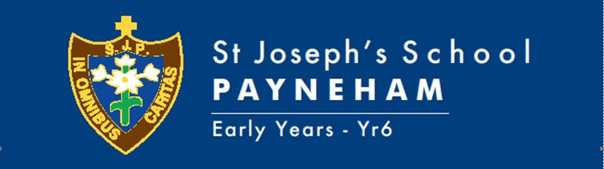
Dear Preschool Families,
Welcome to Term Three 2021. The children have had a bumpy start to the term with a statewide lockdown in Week 1, but we know they are resilient and can’t wait to see their faces back at preschool soon! Under the National Quality Framework, our guiding approach to regulation, assessment and quality improvement for early childhood education, we value our home school partnerships and communication. These term overviews provide one form of communication about the preschool program and preschool happenings. We encourage families to also access the Seesaw app to have a more regular insight into our day and keep up to date with events. We also have our programs displayed near our sign in sheets and would love any input or feedback. This term overview contains some important program information and key dates for the term. https://www.acecqa.gov.au/nqf/about

PLANNED INTENTIONAL LEARNING

At Preschool we operate under the guidance of the Early Years Learning Framework. This is a national curriculum framework that is used in early learning settings. The framework has three main guiding principles – Belonging, Being and Becoming.
Experiencing belonging – knowing where and with whom you belong – is integral to human existence. Children belong first to a family, a cultural group, a neighbourhood and a wider community. Belonging acknowledges children’s interdependence with others and the basis of relationships in defining identities. Belonging is central to the Early Years Learning Framework; in that it shapes who children are and who they can become.
Experiencing being – childhood is a time to be, to seek and make meaning of the world. Being recognises the significance of the here and now in children’s lives. It is about the present and them knowing themselves, building and maintaining relationships with others, engaging with life’s joys and complexities, and meeting challenges in everyday life. The early childhood years are not solely preparation for the future but also about the present.
Experiencing Becoming - A child grows up and moves through stages of early childhood to preparing for school. A child can learn about changes in their relationships, knowledge, understandings, identities and skills through different events and circumstances. Becoming reflects this process of rapid and significant change that occurs in the early years as young children learn and grow. It emphasises learning to participate fully and actively in society.
Belonging, Being and Becoming – the Early Years Learning Framework for Australians.
Concepts discussed and taught at Preschool this term include:
- I belong to the Joeys/Kanga/Koala groups
- I belong to St Joseph’s School
- I have feelings that help me to express my thoughts and needs
- My thoughts and ideas allow me to express myself
- I become aware of fairness
- I develop curiosity, cooperation, confidence, creativity, commitment, enthusiasm, persistence, imagination and reflexivity
- I develop a range of skills and processes such as problem solving, inquiry, experimentation, hypothesising, researching and investigation
- I communicate verbally and non-verbally with others for a range of purposes

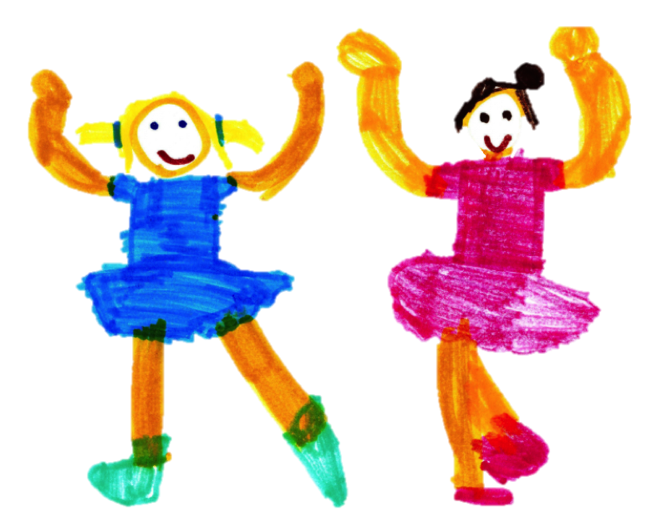
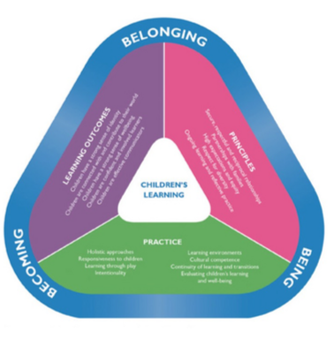
In Numeracy this term we are learning:
- I explore and understand my place and space in the world
- I quantify my world
- I analyse, read and organise the data in my world
- I measure and compare my world
In Literacy this term we are learning:
- I use language to connect with my world
- I understand the language of my world
- I represent my world symbolically
- I engage with texts and make meaning
In Religious Education (Crossways Curriculum) we are learning:
- Knowledge Strands – Church for the World, Moral Life
- Sub-Strand – Disciples of Jesus, Moral Decision Making, Moral Wisdom and Catholic Social Teaching.
- Enduring Understanding – Many people try to be like Jesus, I am learning about positive choices, Jesus shows us how to be loving to everyone.
In Child Protection Curriculum we are learning:
- FA2 : Relationships
- FA3: Recognising and Reporting Abuse
REMINDERS
Book week Parade Day- Thursday 26th August (week 6)

School Photo Day- Friday 27th August (Week 6- for Kanga Groups)

School Photo Day- Tuesday 31st August (Week 7- for Joey & Koala Groups)

Father’s Day- Sunday 5th September (Week 7)

Last Day of Term 3 – Thursday 23rd September (Week 10)

Pupil Free Day – Friday 24th September (Week 10)

Regards,
The Preschool Team

