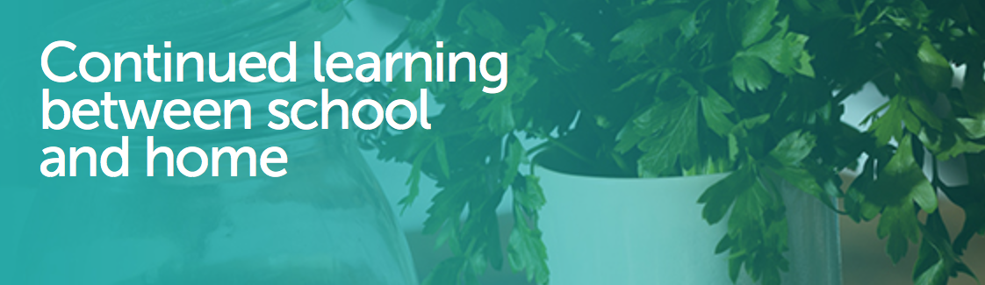
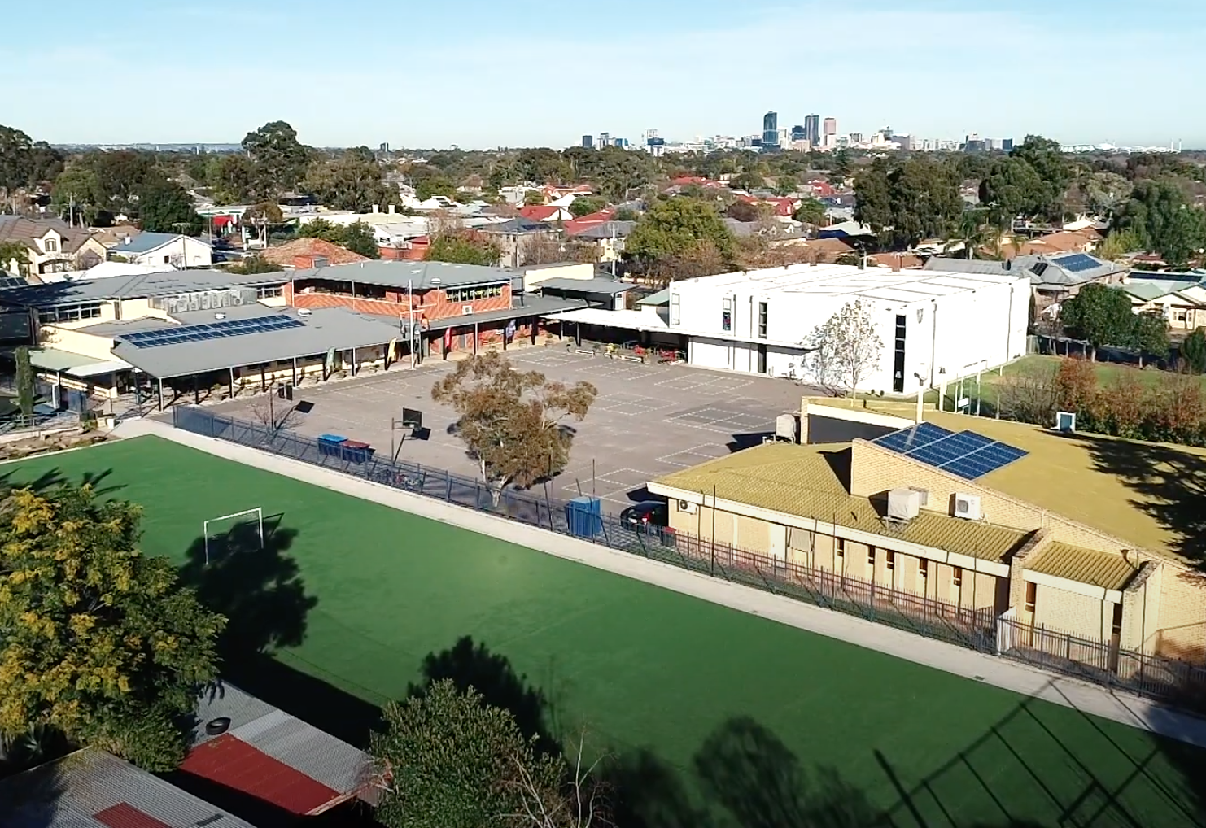
Supporting students, families and teachers for continued learning between school and home.

Learning from Home Guide

At St Joseph’s School, we are proud that we will be able to offer all our students’ online learning in these exceptional circumstances that require school closure. In such circumstances, our commitment is to provide this alternative means of education in the form of an Online Learning Plan. While Online Learning doesn’t replicate onsite learning, our teachers can deliver powerful instruction that allows students to meet expected achievements in an online environment.
While this is a time of uncertainty and challenge, it is also a time that provides us with unlimited opportunities to connect with new ideas and ways of working online with the students
The purpose of this document is to outline how St Joseph’s will continue to offer a Learning model, in an online environment.
Online Learning Platforms
The following Online Platforms used at St Joseph’s
  - Seesaw is the online Learning platform used in the Junior Primary (P-3).
  - Microsoft Office 365 tools Teams is the online Learning platforms used in the Primary School (4-6)
  - Office 365 tools (e.g., email, shared docs, OneNote,) are other online collaboration tools for online instruction.
Time expectation for students per day
- Reception -2 (2 hours)
- Year 3 (3 hours)
- Year 4-5 (3.5 hours)
- Year 6 (4 hours)
ROLES AND RESPONSIBILITIES OF PARENTS
Setting up a learning environment
We recognise that every home is different. Where possible, it’s important to provide a quiet and comfortable learning space. Your child may have a regular place for doing homework under normal circumstances, but this space may not be suitable for an extended period of time. For some families, having all children around one table may work best. Where possible, extended learning should take place in a space your family shares. For example, a lounge room or dining room.
Supporting your child
- Students need routine and certainty. You can support your child by:
- Creating clear routines and expectations;
- Providing a safe and quiet space to work;
- Supervising them at a level appropriate to their development;
- Checking in with them often to help manage and pace their work;
- Monitoring how much time they spend online and balancing this with physical activity; and
- Checking communication from the teacher(s) and staying in contact with the school.
Communicating with your child
You can stay involved with your child’s learning by asking them questions. This helps them to manage the instructions they receive from the school and to set priorities for their learning.
At the start of the day, ask:
- What are you learning today?
- What are your learning targets or goals?
- How will you be spending your time?
- What resources do you need?
- What support do you need?
At the end of the day, ask:
- What did you learn from today?
- What did you enjoy about today’s activities?
- What was challenging? How can we work through the challenge?
- What went well today? Why did it work well?
- Are you ok? Do you need to ask your teacher for something?
- Do you need help with something to help tomorrow be more successful?
Parental Support
Parents and caregivers can support their children in a range of ways. This could include furthering teacher’s discussions about establishing a space for successful learning in the house that is visible to parents and caregivers, but ideal for maintaining concentration. Other suggestions for maintaining a safe and quiet learning environment conducive for learning may also include:
- Ensuring students are accessing appropriate content.
- Checking filters provided by their home network.
- Guidelines for rules regarding the time spent on devices.
- Setting expectations as soon as distance learning is implemented, to maintain routines that support learning.
Access to Teachers
Teachers are available between9.00am and 3.00pm each day and should be able to respond to questions depending on demand. Teachers may respond to parent emails after this time where time permits, however all contact with students will cease after 3.00pm. I ask parents to encourage students to respond using their platform, while parents can contact teachers via email.
Access to Resources
For families who do not have Internet or a device at home for your child to access, please contact the classroom teacher to provide you with a learning pack.
Offline Learning
Not all learning will need to be completed online. To add variety and reduce screen time, teachers may instruct students to read, draw, create or engage in other learning activities within the home environment.
Student Safety
As teachers investigate new ways to safely communicate with students online, we wish to reassure you that staff will strictly observe all Protective Practice Protocols for communicating with students. We ask that all email communication from students is via their school email account and that in a situation where students might be engaged in video conferencing that students:
- Participate in an appropriate setting (a student’s bedroom is not suitable) ensure that anything visible in the background is blurred
- Are appropriately dressed
- Use respectful language at all times
Parental supervision of students engaging in online learning is essential to student safety
Assessment and Feedback
Teachers will expect that students are completing tasks and submitting them according to teacher instructions. If students experience any difficulties with work completion or submission, an email to the teacher from the student (or parent/caregiver) will enable teachers to provide additional support and flexibility with deadlines if needed.
WELLBEING
The current situation we are facing can have increased levels of anxiety for many people including our children. It is important to remember that they look to trusted adults in their lives to remain calm and answer any questions they may have in an open and honest manner.
Your child also needs daily-unstructured playtime; spending time with family will allow your child to feel connected. Hence, time together and playing games is essential. Some ideas include: UNO, Connect-4, etc.; football, soccer, basketball in the backyard; throwing a frisbee at the local park; walking the dog as a family; and so on. Meditation and mindfulness activities, like colouring-in are also a great way for children to relax and decompress.
For more information about online learning, and for links to resources to support parents, please use the websites linked below.

https://www.education.sa.gov.au/our-learning-sa

Department for Education Parent Resources

Setting up for Learning at Home
Preparing for Online Learning – Information for Parents and Caregivers
Preparing for Online Learning – Information for Students
Staying Healthy and Active while Learning at Home
Reading at Home

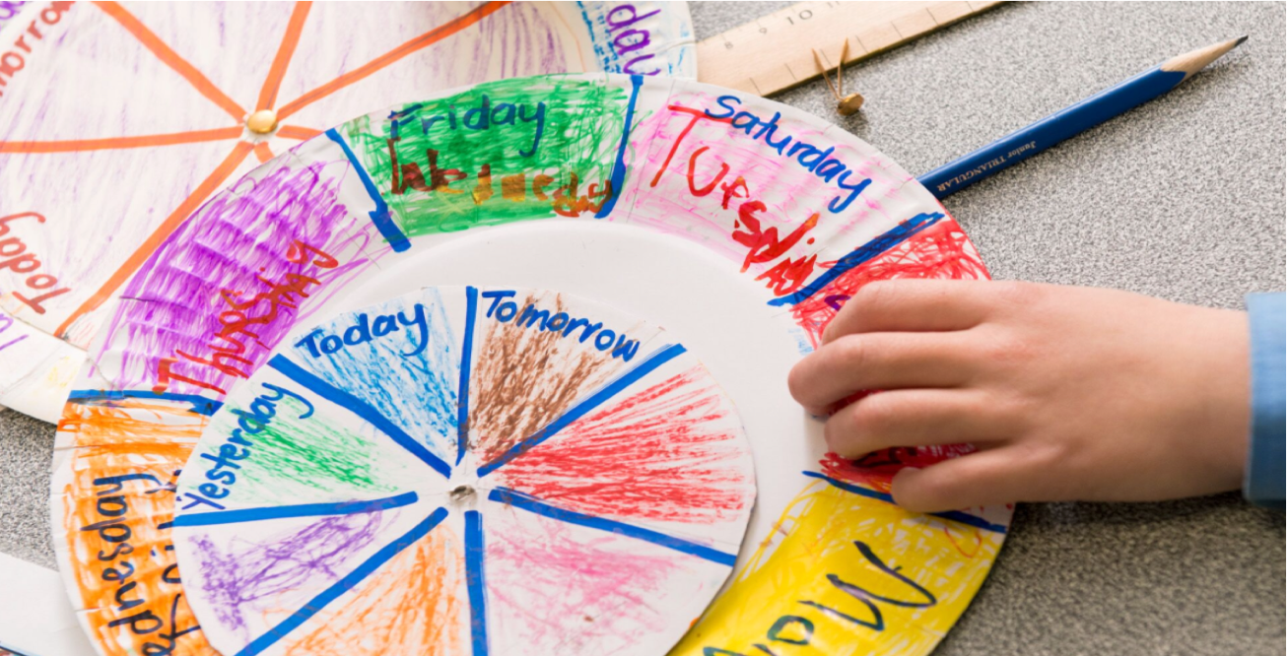
PRESCHOOL - YEAR SIX

Home and school learning will include Literacy, Numeracy, Religious Education and activities from other learning areas as well as specialist subjects. Usually, during the afternoon the children will engage in CARE activities (Calm & Connect, Artistic, Read & Write, Exercise & Energise). An overview of these learning activities can be found in each of the Year level timetables.
Morning Connection/Roll Call
Each morning students who are learning from home and school will access their specific learning platform and view the morning connection video posted by their teacher. Students will need to respond to this video, and this demonstrates students are present for learning. The teachers will take the roll from these responses.
- If your child is not participating in the learning for any reason whether at home or at school (e.g. illness, medical appointment, family event, etc.) please continue to follow the usual protocol of informing the teacher via email.
We recommend that all children spend no more than 45 minutes per day during learning time on a device
- PRESCHOOL
Preschool teachers will share learning programs via SEESAW. At the start of each day, teachers will post suggested inquiry and play-based learning opportunities that could occur at home.
Expectations of student’s learning
- Proud moment of the week: at least once a week we ask parents and caregivers to share a photograph with a small explanation regarding their child’s success. This can be something the child has simply enjoyed or a moment where the child has stayed focused over a long period of time.
- Children will engage in exploratory play opportunities (please limit use of TV/iPad time). Hands on experiences will support the holistic development of your child.
- Children are supported to have a go at the provided provocations. Please do not put pressure on your child if they would rather engage in alternative play experiences.
- Children and their parents and caregivers to share at least one story together per day. Reading is imperative to children’s oral language and writing skills.
- Have fun! Please remember, our precious children are under 5 years of age – learning is meant to be enjoyable. We want our children to love learning! You can contact us direct via email if you have any questions.

MID YEAR RECEPTIONS
Each morning, we will post five different learning activities in the following areas:
- Literacy
- Numeracy
- Fitness
- Song
- Inquiry
This is to provide some choice and flexibility for you and your child. We encourage students to attempt all activities for the day and upload any completed work. We understand that all children work at different paces and some of you will be working from home so please adapt activities as necessary to suit your family circumstances.
To access these activities, you will need to sign in using your child’s home learning code. From here, you will be able to upload your child’s completed work (when required).
Lesson | Subject
1 | Literacy
Brain Food
2 | Song of the day
Recess
3 | Numeracy
4 | Fitness
Lunch
5 | Inquiry
6 | Play
RECEPTIONS
Reception teachers will use their class page on SeeSaw to provide daily updates to parents and students.
We will provide your child with a variety of learning activities and be available, via email, for questions and support. Reception students will be required to submit their completed learning activities via SeeSaw. Your child will be supplied with workbooks and activity packs to complement their online home learning.
You can contact us direct via email/Seesaw if you have any questions.
- Amanda Karam - akaram@stjopayn.catholic.edu.au
- Lucy Martino - lmartino@stjopayn.catholic.edu.au
- Joyce Nero - jnero@stjopayn.catholic.edu.au
- Adriana Graziani - agraziani@stjopayn.catholic.edu.au
- Jen Annetta - jannetta@stjopayn.catholic.edu.au

- Expectations of student’s learning
- Attempt all work set.
- Remove any distractions that might stop being focused and completing work.
- Ensure there is a healthy balance between screen time and other activities. During break times please avoid using devices or technology.
We believe that as we move into the online learning space from home, your child’s learning is a three-way partnership between the child, parent and teacher. Our partnership with your child and yourself is crucial.

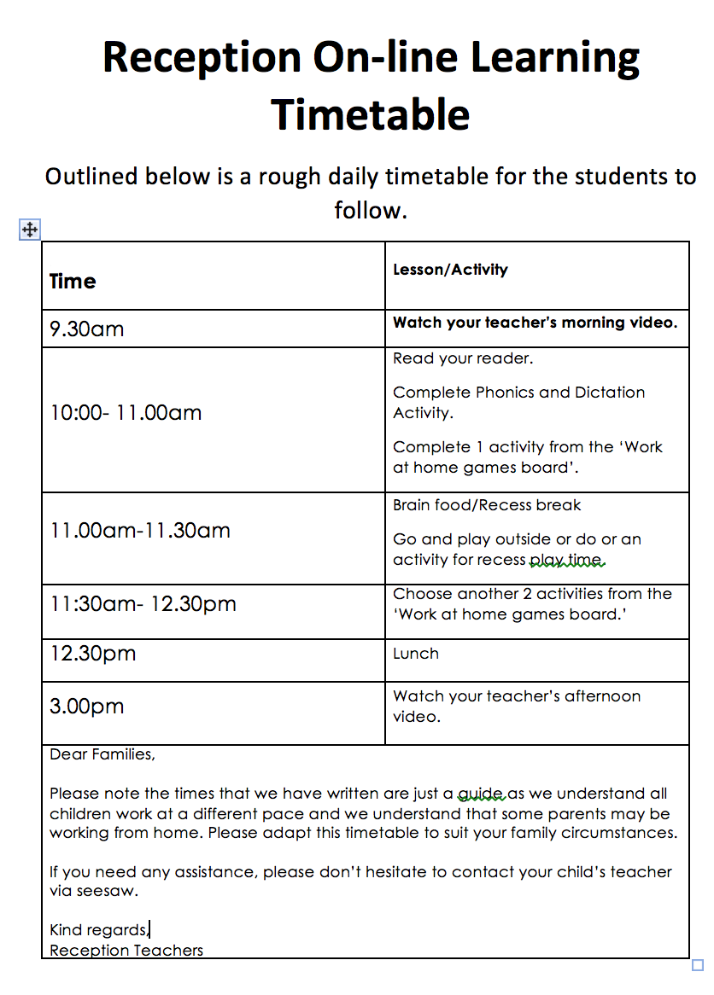

YEAR ONE
Year 1 teachers will use their class page on SeeSaw to provide daily updates to parents and students. You and your child have been supplied with access codes to enable uptake of the SeeSaw learning platform. We will provide a variety of learning activities and be available for questions and support.
Year 1 students will be required to submit any learning activities that will occur via SeeSaw. Your child will be supplied with a workbook and activity packs to complement online home learning. Please note specialist teachers will also provide lessons for students.
- Sonia Tronnalone - stronalone@stjopayn.catholic.edu.au
- James Cummings - jcummings@stjopayn.catholic.edu.au
- - jmprestia@stjopayn.catholic.edu.au

- Expectations of student’s learning
- Attempt all work set.
- Remove any distractions that might stop being focused and completing work.
- Ensure there is a healthy balance between screen time and other activities; during break times avoid using a device or technology.
- We believe that as we move into the online learning space from home, your child’s learning is a three-way partnership between the child, parent and teacher. Our partnership with your child and yourself is crucial.

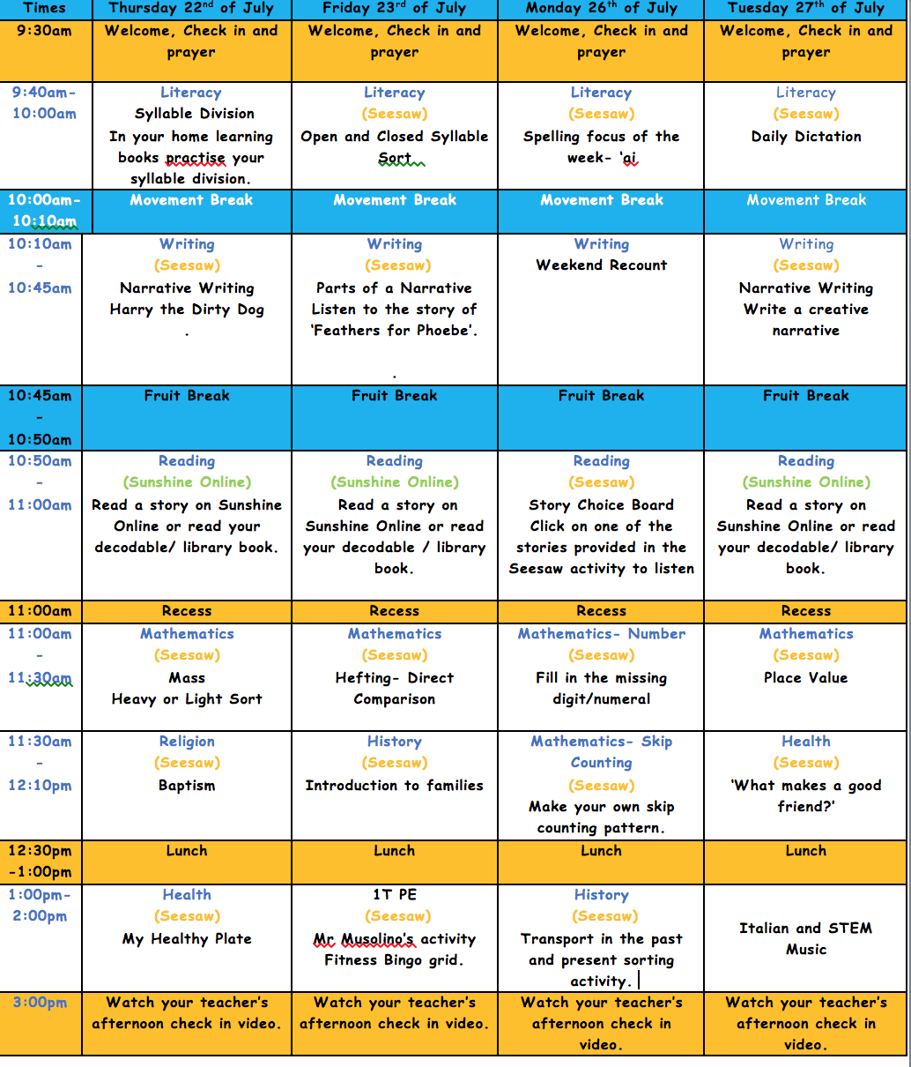
YEAR TWO
Year 2 teachers will use their class page on SeeSaw to provide daily updates to parents and students.
You and your child have been supplied with access codes to enable uptake of the SeeSaw learning platform.
We will provide a variety of learning activities and be available for questions and support. Year 2 students will be required to submit learning activities they complete via SeeSaw.
Please note specialist teachers will also provide lessons for students.
Parents can contact their class teacher/s direct via email or SeeSaw if they have any questions.
- Shendelle Watters - swatters@stjopayn.catholic.edu.au
- Tania Tryant - ttryant@stjopayn.catholic.edu.au
- Michael Musolino - mmusolino@stjopayn.catholic.edu.au
- Expectations of student’s learning:
- Attempt all work as best you can, when you can.
- Remove any distractions that might stop being focused and completing work.
- Ensure there is a healthy balance between screen time and other activities (avoid using device or technology during a break).
- We believe that as we move into the online learning space from home, a three- way partnership between the child, parent and teacher is essential.
- The following daily plan has been created to assist you in continuing your child’s learning at home. We understand, however, that a daily plan could look different for every family.
- This is only a guide. There is a limit with how much you can record in one hit. As a result, there is a 5- minute limit for anything that will be recorded in SeeSaw.

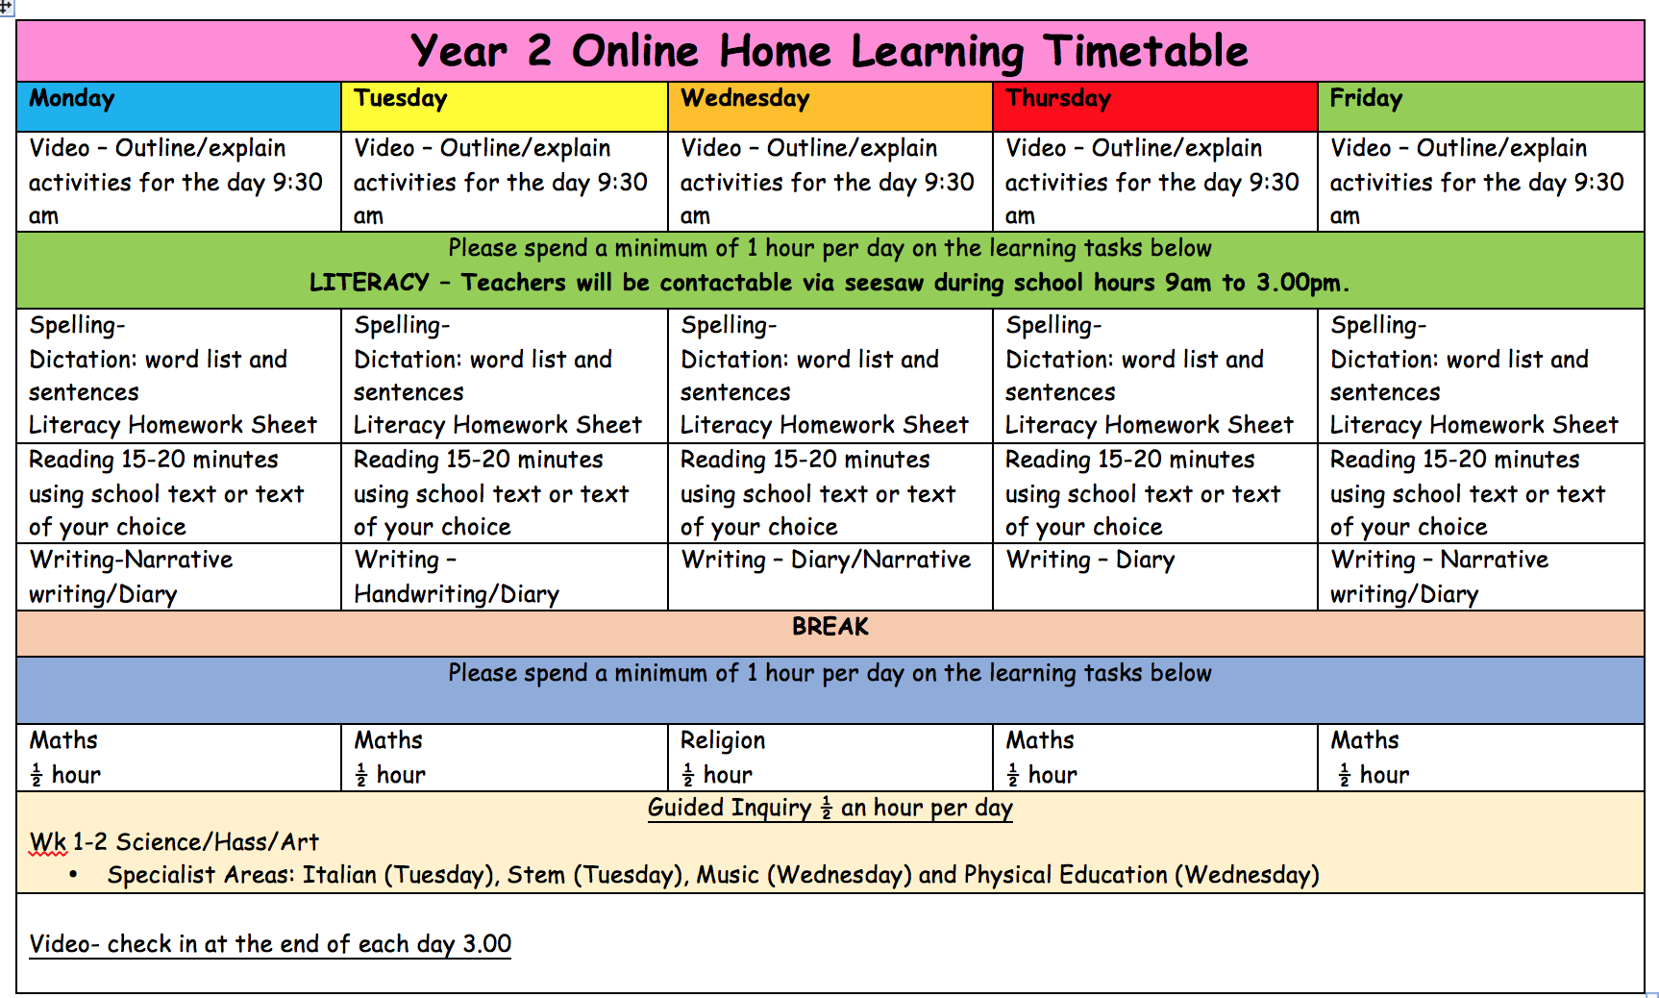
YEAR THREE
The Year 3 teachers will use Seesaw to provide daily updates to students and email for communication with parents and caregivers.
The teachers will make contact with students at 9.30am to provide instruction for the day’s learning tasks.
The teachers will provide a variety of learning activities and will be available for questions and support at the designated times.
Students can work on the learning activities independently or with support from their parents or another adult.
Parents can contact their class teacher/s direct via email if they have any questions:
- Angela Scarpantoni - ascarpantoni@stjopayn.catholic.edu.au
- Margaret McConnell - mmcconnell@stjopayn.catholic.edu.au

- Expectations of student’s learning:
- Attend the daily online lesson on Teams meeting at 9.30am.
- Remove any distractions that might stop being focused and completing work.
- Attempt all set work and communicate with teacher if there are any questions or problems.
- Ensure there is a healthy balance between screen time and other activities.
- Keep the learning a happy experience and don’t put too much pressure on yourself.

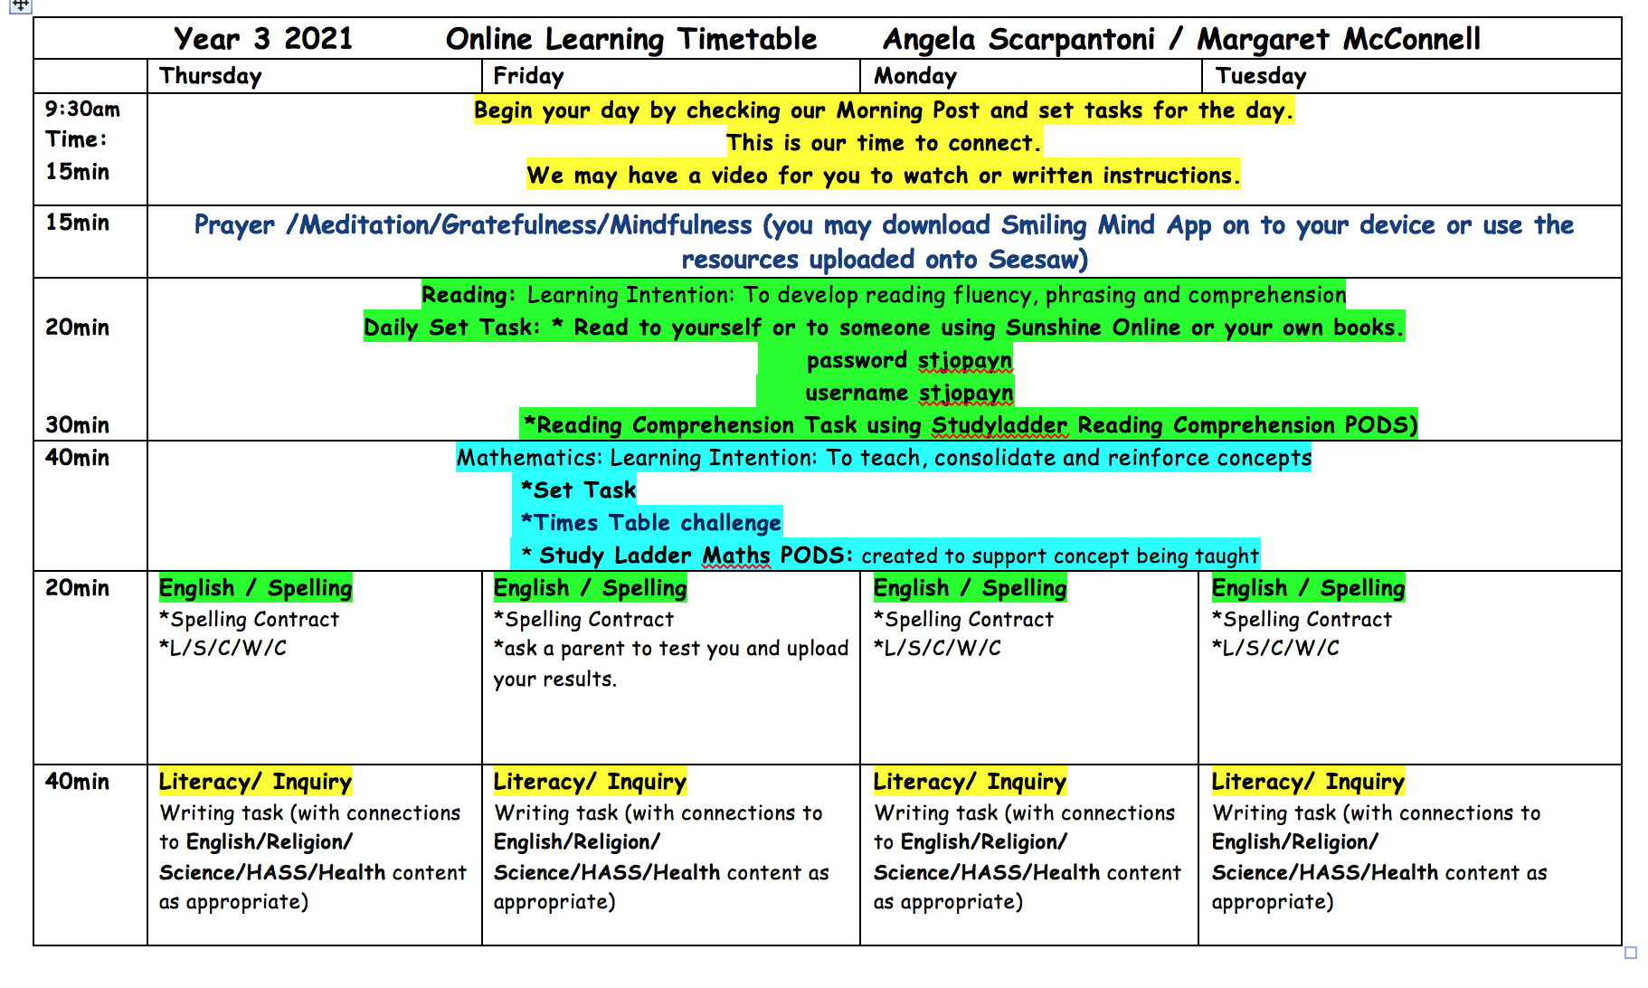

YEAR FOUR
The Year 4 teachers will use the Teams app to provide daily updates to students and email for communication with parents and caregivers.
From 9.30am teachers will be online for students to make contact. Parents and caregivers are asked to email teachers if they have any questions. Please note: Teams is for student and teacher use only.
The teachers will provide a variety of learning activities via Teams and will be available for questions and support at the designated times.
Students can work on the learning activities independently or with occasional support from their parents or another adult. Some lessons may involve whole class or small group real-time conversations or live video streaming.
Specialist teachers will also provide lessons for students.
Parents can contact their class teacher/s direct via email if they have any questions
- Bernardette Robinson - brobinson@stjopayn.catholic.edu.au
- Rosanna Parella - rparella@stjopayn.catholic.edu.au
- - krowlett@stjopayn.catholic.edu.au
Expectations of student’s learning
- Attend the daily online lesson on Teams.
- Remove any distractions that might stop being focused and completing work.
- Attempt all set work and communicate with the teacher if there are any questions or problems.
- Submit all due work to teachers as instructed (by the teacher).
- Ensure there is a healthy balance between screen time and other activities; during break times avoid using device or technology.

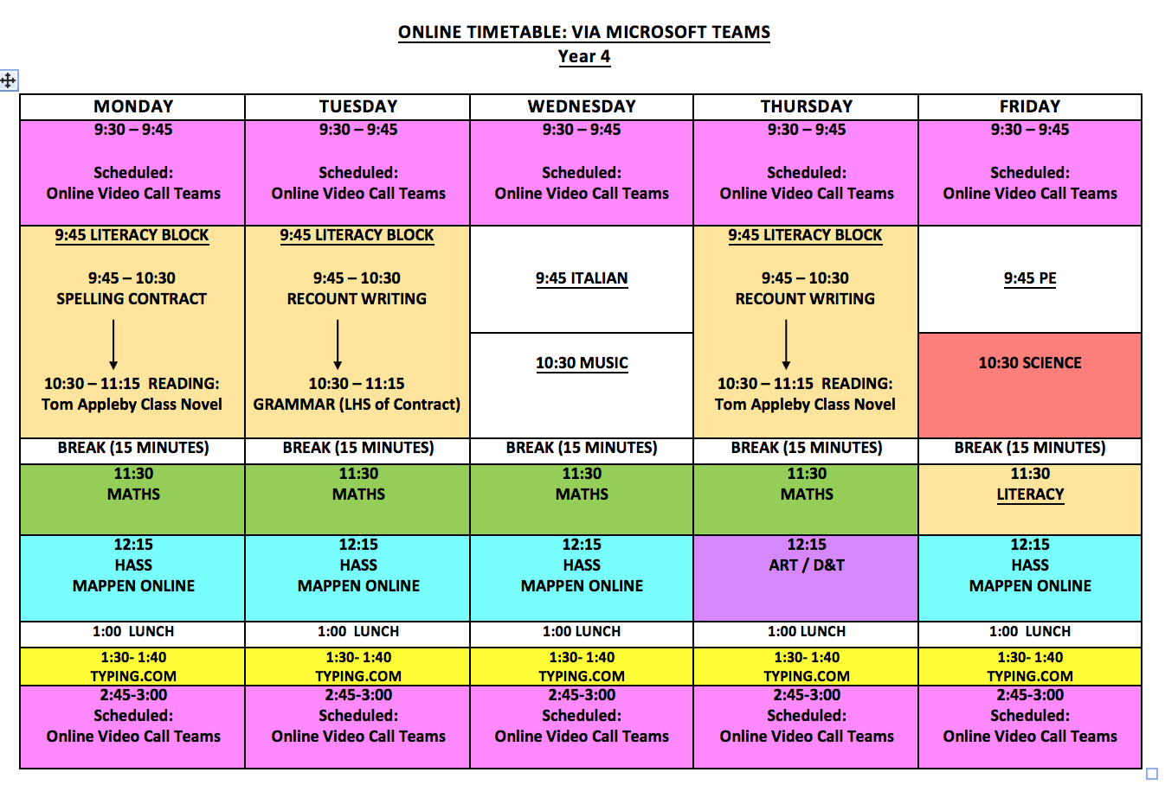
YEAR FIVE & SIX
The Year 5 and 6 teachers will use the Teams app to provide daily updates to students and email for communication with parents and caregivers.
From 9.30am teachers will be online for students to make contact. Parents and caregivers are asked to email teachers if they have any questions. Please note: Teams is for student and teacher use only.
The teachers will provide a variety of learning activities via Teams and will be available for questions and support at the designated times.
Students can work on the learning activities independently or with occasional support from their parents or another adult. Some lessons may involve whole class or small group real-time conversations or live video streaming.
Specialist teachers will also provide lessons for students.
Parents can contact their class teacher/s direct via email if they have any questions
- Yvette Vingelis - yvingelis@stjopayn.catholic.edu.au
- Adriana Graziani - agraziani@stjopayn.catholic.edu.au
- Matthew Annetta - mannetta@stjopayn.catholic.edu.au
- Michael Mastrangelo - mmastrangelo@stjopayn.catholic.edu.au
- Expectations of student’s learning
- Attend the daily online lesson on Teams.
- Remove any distractions that might stop being focused and completing work.
- Attempt all set work and communicate with the teacher if there are any questions or problems.
- Submit all due work to teachers (as instructed by the teacher).
- Ensure there is a healthy balance between screen time and other activities; during break times avoid using a device or technology.

- 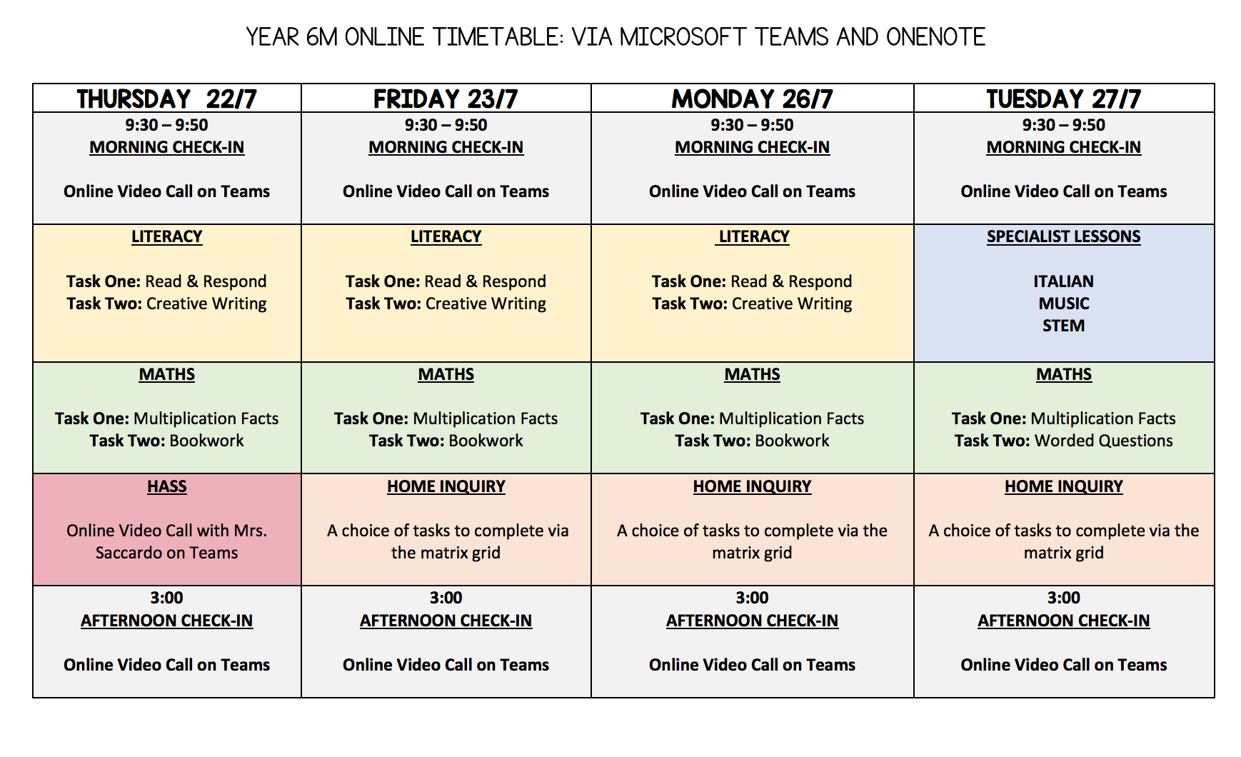

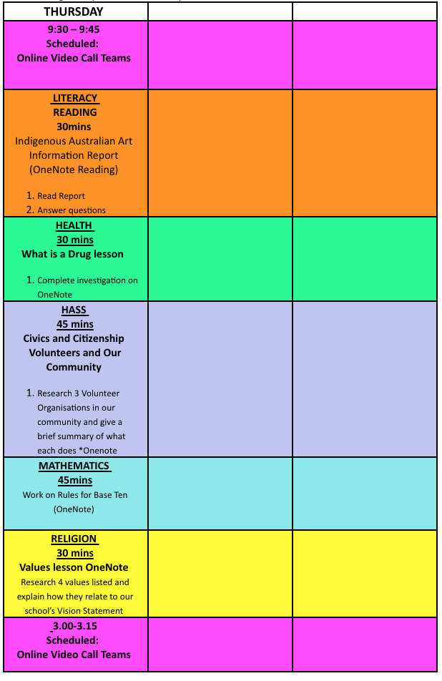
YEAR 5

